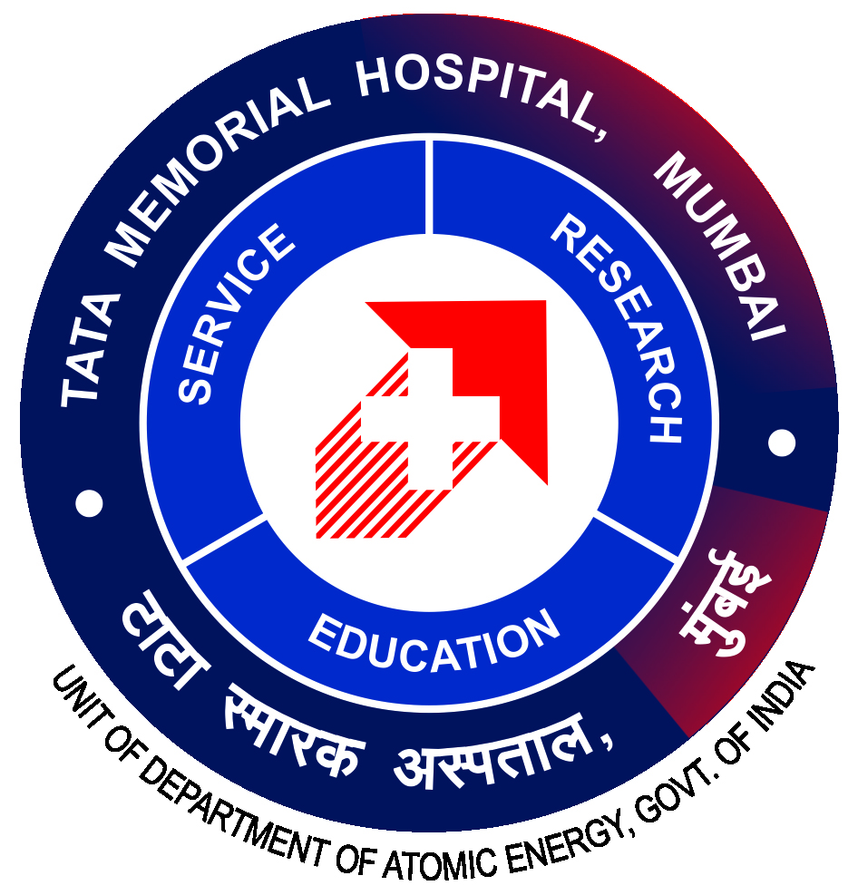

**TATA MEMORIAL CENTRE**

**A Grant-In-Aid Institute of Department of Atomic Energy, Government of India**

**(TATA MEMORIAL HOSPITAL)**

**PAREL, MUMBAI – 400 012**

**OFFICE OF DIRECTOR (ACADEMICS)**

**04.11.2024**

|  |  |
| --- | --- |
| **ADVT NO: TMC/AD/146/2024** | |
| **Last Date of Online Applications : 25.03.2025** | |
| **Name of Workshop** | **“Principles and Practice of Cancer Prevention and Control”** |
| **Eligibility** | Medical Officers / Consultants / Research Fellows / Residents / Dentists / Clinical Trail Coordinators / Post Graduate Students |
| **Fees**  **(Non Refundable)** | Rs.1500/- (Rupees One Thousand Five Hundred Only) |
| **Time** | 9:00 A.M. TO 5:00 P.M. |
| **Duration** | **02 days (26.03.2025 and 27.03.2025)** |

Application forms are available at: <https://tmc.gov.in> in Training Program under Events.

Course fees are inclusive of breakfast, lunch & snacks. The amount will be credited to **Workshop on Cancer Prevention and Control Account No. 5384 (New Account Created).**

**Participants can contact Department of Preventive Oncology for any Queries**.

Department Address:

Department of Preventive Oncology,

Service Block, 3rd Floor

Tata Memorial Hospital Parel Mumbai – 400012

Contact No. 022-24177000 Ext - 4670 / 4649 / 4632

**DR. S.D. BANAVALl**

**DIRECTOR (ACADEMICS), TMC**